ILOVEMYLIBRARY MERCHANDISE

STUDENT’S INFORMATION
Fullname:
Student number:
Course:
Department:
E-mail:
Contact number:

“I need. I value. I Love my Library.” Campaign merchandise are available at the Admin Section of the EnggLib2. For more information, contact us through
e-mail at library@engglib.upd.edu.ph, or call us at 920-9060 and 434-8638.

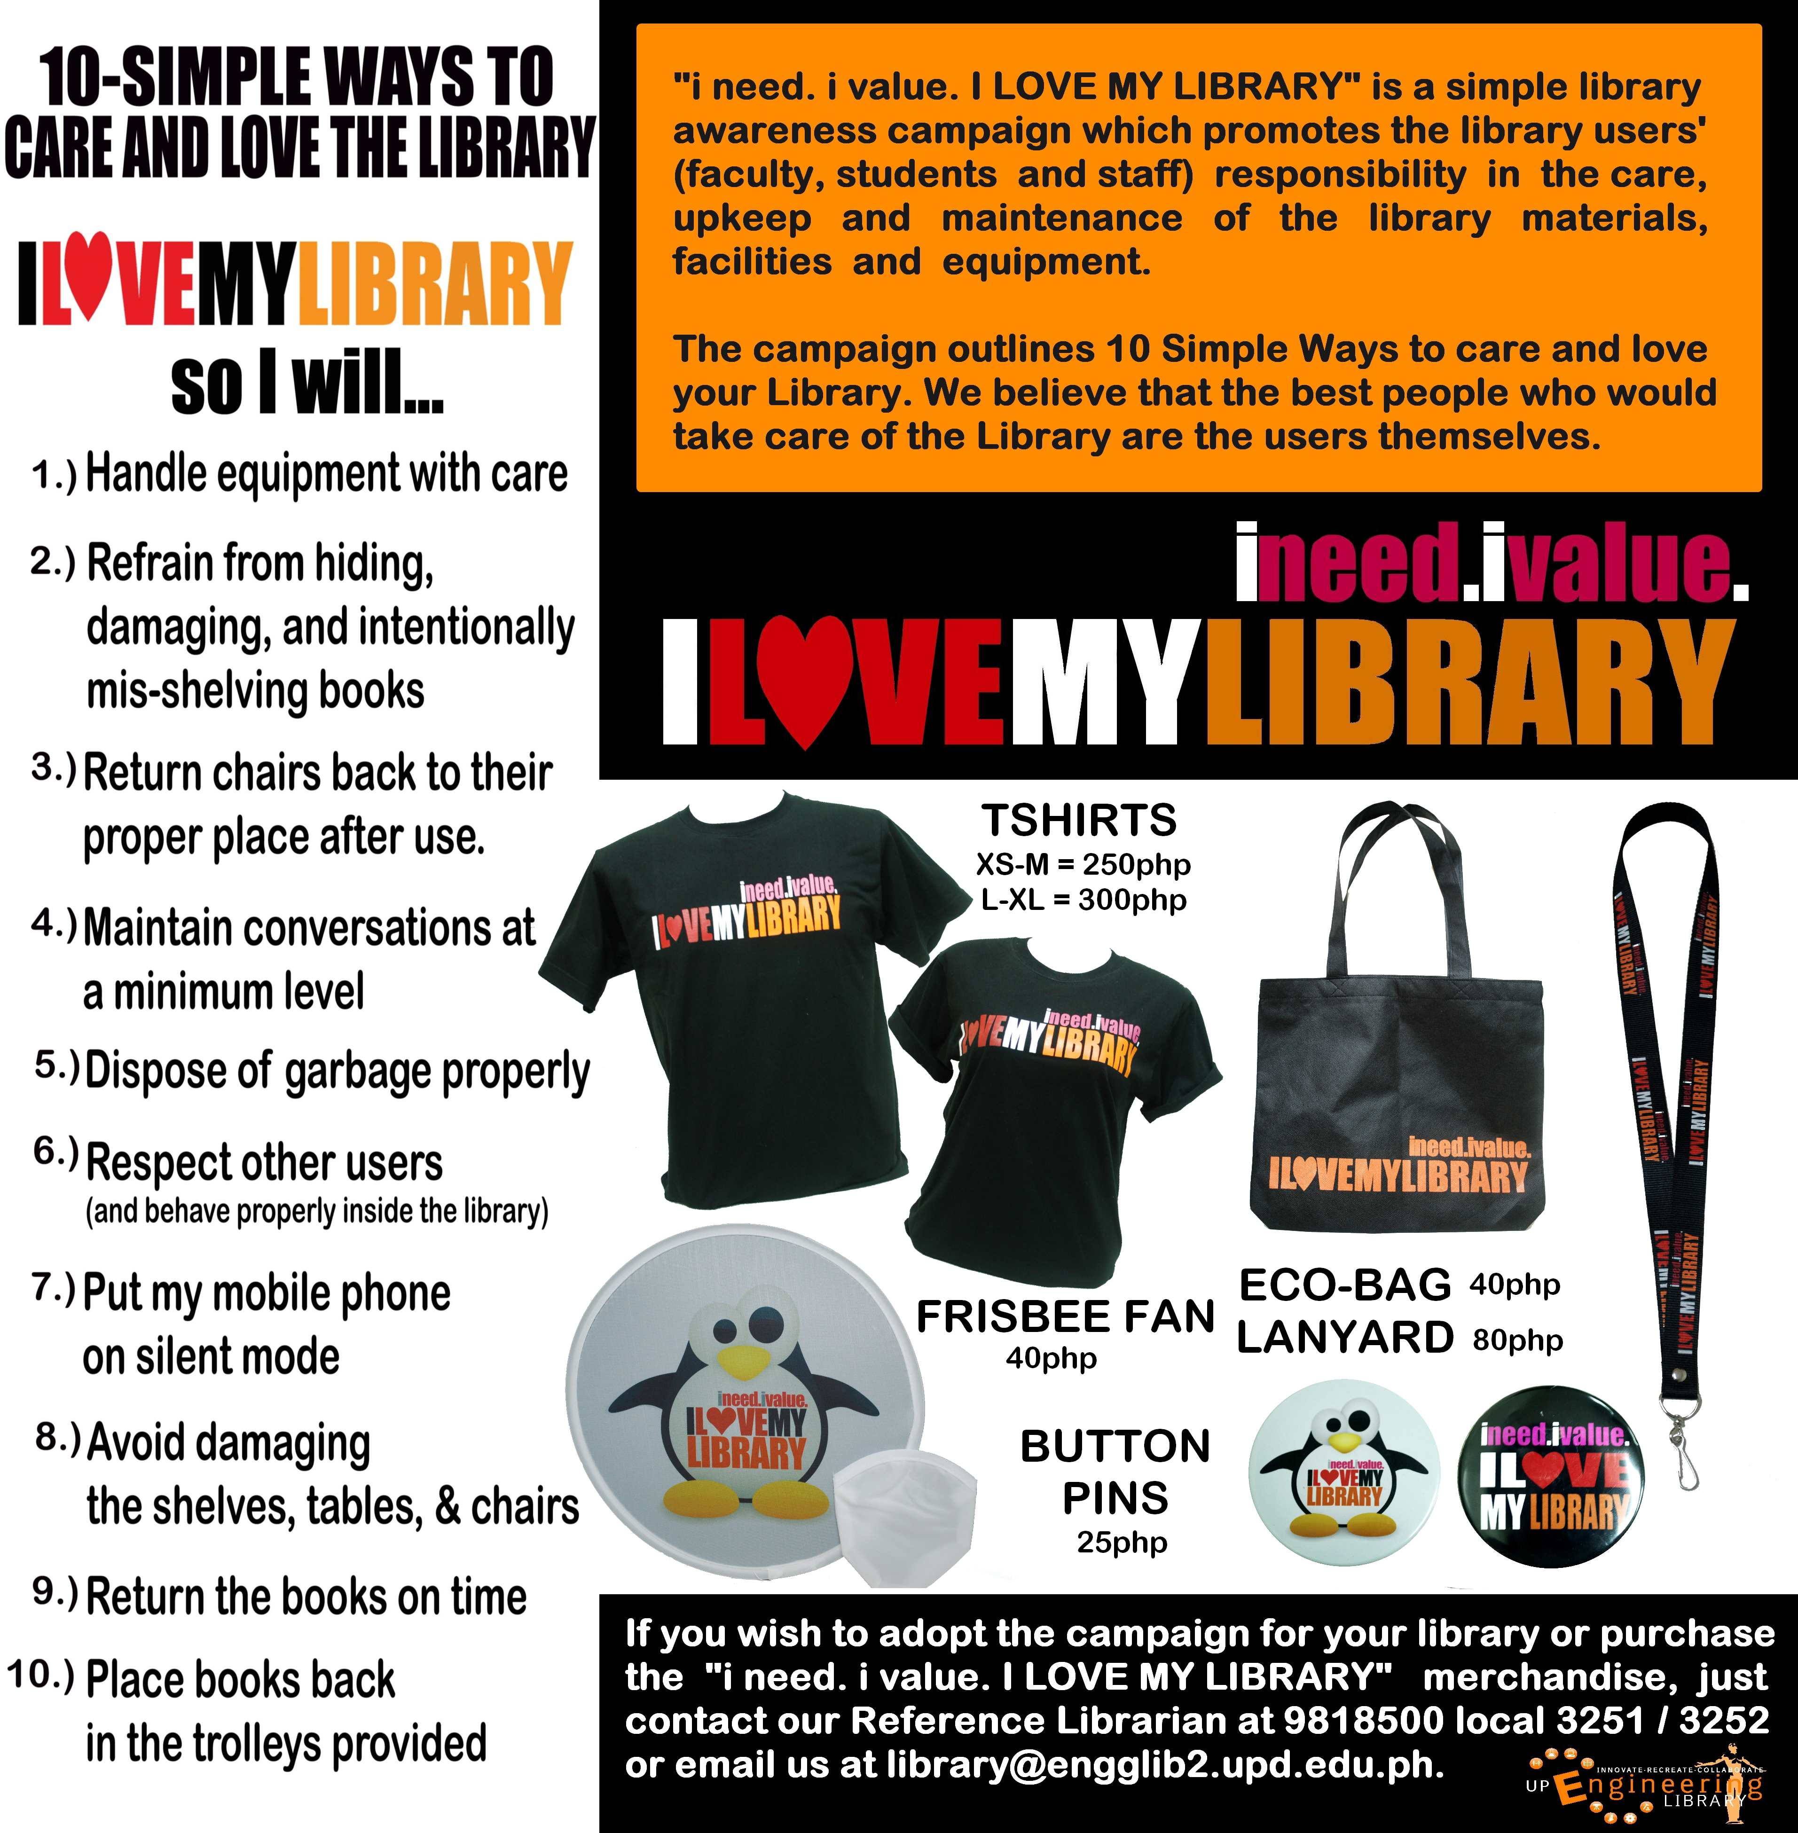

Read more about the campaign at:

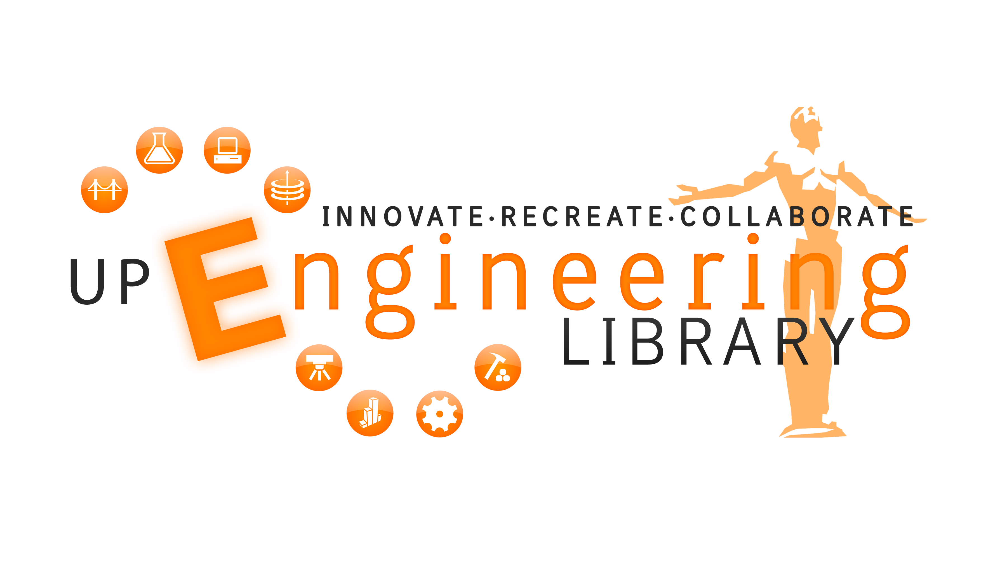

A campaign initiated by the U.P. College of Engineering Library www.engglib.upd.edu.ph

“i need. ivalue. ILOVEMYLIBRARY" is a simple library awareness campaign which promotes responsibility among library users (faculty, students and staff) in the care, upkeep and maintenance of the library materials, facilities and equipment.

The campaign outlines 10-Simple Ways to care and love your Library. We believe that the best people who would take care of the Library are the users themselves.

Student’s copy

ILOVEMYLIBRARY PLEDGE

I , do solemnly swear that I will help

preserve and maintain the College of Engineering Library s furniture, library materials, and equipment. I will abide by the rules and regulations therein. I will do my best to turn this Library into a place conducive for learning to benefit the future generation.

So help me God.

Library’s copy

ILOVEMYLIBRARY PLEDGE

I , do solemnly swear that I will help

preserve and maintain the College of Engineering Library’s furniture, library materials, and equipment. I will abide by the rules and regulations therein. I will do my best to turn this Library into a place conducive for learning to benefit the future generation.

So help me God.

Signature

Signature

